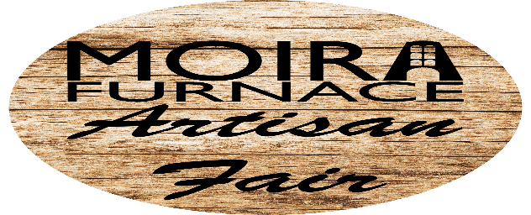

Saturday 26th – Monday 28th August 2023
Name: Telephone number:
Address:
Postcode:
Email:
Business Name:
Items to be sold:
If you have a variety of different items for sale, please could you put the % of each. For example - 10% Bead Jewellery; 10% Cards; 80% Soap or bath products.
Note - items should be at least 90% handmade/handcrafted, unless otherwise agreed.
Stall holders found to have ‘bought’ in items will be asked to remove them from sale unless prior agreement has been sought.
One day = £40 Two days = £70 Three days = £90
Saturday 26th - ☐ Sunday 27th - ☐ Monday 28th - ☐
Please note, this is an INDOOR event. We will supply one 6 foot long table and one chair per seller.
Do you hold public liability insurance? Yes ☐ No ☐
This is required and proof of cover will be asked for in advance.
Signed: Dated:
How did you hear about this event?
Please contact us on 01283 224667 or email 0ffice@moirafurnace.org if you have any questions.
Payment Methods
An invoice will be drawn up from the information provided on this form. Please DO NOT pay anything until an invoice has been issued. This is confirmation of your space in the fair.
When paying the invoice, the invoice number must be used as the reference.
Please email this booking form to: office@moirafurnace.org
Or post to: Moira Furnace Museum Trust, Unit 8, Furnace Lane, Moira, Swadlincote, DE12 6AT
Please see below for further information and ensure you have read the full terms and conditions prior to the event.
1. Each seller will be allocated a 6 foot table and chair within a marquee. There will be enough room to get between yours and you neighbours table as needed.
2. It is a condition of our own insurance policy that sellers will also have to have their own Insurance and Public Liability cover. Any stall selling food items must confirm with the organiser in advance how they comply with current UK food hygiene legislation.
3. Set up will be from 8.00am. You will not be able to get onto site until this time. Set-up needs to be completed and vehicles parked behind the marquee as directed or in the car park by 10am. Take-down can only start after the fair closes at 4pm unless otherwise told by the organisers.
4. Sellers who are here for more than one day can either pack up completely at the end of the day or leave their stock in the marquee. MFMT will have a presence on site but cannot guarantee the safety of the items and are not responsible for any loss or theft that may occur. MFMT will take all reasonable precautions to avoid this to the best of their abilities.
5. No raffles, tombola’s, lotteries, or prize draws will be allowed unless previously agreed with the organiser.
6. The fair is open to the general public from 10.00am - 4.00pm. Stall holders must be present and taking sales throughout this period.
7. Tables will be allocated before the event and their numbers will be clearly marked. Please report to a member of staff on arrival to confirm your table. The MFMT tries hard to accommodate all requests but will look to prioritise disability and access issues above any other requests. Requests to move with reasons such as perceived low footfall will not be looked at.
8. Full payment will be needed upon receipt of invoice within the 30-day payment terms. Payments are not to be made until an invoice has been issued. This is confirmation of booking, and the invoice number is to be used as reference when paying. The organiser reserves the right not to accept bookings for any reason, and to reallocate space not paid in full by the due date.
9. Stall holders should not arrange their own replacements if they are unable to attend. This is in fairness to stall holders on any waiting list that are maintained by the organiser.
10. If the event is cancelled by the organiser, then any payments received will be refunded in full minus a 10% admin fee. If the stall holder cancels more than one month before the event, then the booking fee less 10% admin fee will be refunded. If cancelled less than one month before the event no money can be refunded. This is at the discretion of the organiser.
11. The organiser accepts no liability for loss of earnings because of any circumstances, nor any other action by any third party beyond their control.
12. In the interest of fairness and in an attempt to offer the best experience for both visitors and stall holders, we are limiting the number of similar item stalls per fair to 2. If you apply for a table and we already have 2 other stalls selling similar items, we will not accept your booking but would look to offer you another date, where possible, or place you on the reserve list for that date.
14. If, for any reason, you cannot make it to the fair, the office needs to be informed as soon as possible in order for MFMT to source a replacement. If no message is received by the start of the fair (10am) at which you were due to attend, MFMT reserve the right to charge a no-show fee of £20, the amount lost due to not being able to offer the space to another crafter. Emails or phone messages are acceptable ways of contacting us. This is at the managers discretion.

